Table of Contents
STANDARD AGREEMENT 2
EXHIBIT B: DEBARTMENT CERTIFICATION FORM 27
EXHIBIT C: DISADVANTAGED BUSINESS ENTERPRISE INFORMATION FORM 28
EXHIBIT D: LEVINE ACT DISCLOSURE STATEMENT 31
EXHIBIT E: PAYEE DATA FOR 35
EXHIBIT F: VENDOR ACH/DIRECT DEPOSIT AUTHORIZATION FORM 37
EXHIBIT 10-K: CONSULTANT CERTIFICATION OF CONTRACT COSTS AND FINANCIAL MANAGEMENT FORM 39
EXHIBIT 10-I: NOTICE TO PROPOSERS DBE INFORMATION 42
EXHIBIT 15-H: DBE INFORMATION - GOOD FAITH EFFORTS 45
EXHIBIT 10-O1: CONSULTANT PROPOSAL DBE 48
EXHIBIT G: FAIR EMPLOYMENT PRACTICES ADDENDUM 50
EXHIBIT H: NONDISCRIMINATION ASSURANCES 51
APPENDIX A TO EXHIBIT H 54
APPENDIX B TO EXHIBIT H 55
APPENDIX C TO EXHIBIT H 56
APPENDIX D TO EXHIBIT H 57
EXHIBIT I: SACOG REQUIRED SUPPORTING DOCUMENTATION FOR INVOICES 58

Due to the nature of this specific RFQ, SACOG recognizes the need for substantial revisions to the SACOG’s Standard Agreement to accommodate the needs of the specific projects. These revisions will be made during contract negotiations but will not include any changes to federal or state requirements herein.

SACRAMENTO AREA COUNCIL OF GOVERNMENTS

STANDARD AGREEMENT

THIS AGREEMENT (“Agreement” or “Contract”), is made and entered by and between the SACRAMENTO AREA COUNCIL OF GOVERNMENTS, a joint powers agency (hereinafter “SACOG”), through its duly appointed Chief Executive Officer, and ______(Vendor Capital Letters)__, a (type of entity (i.e., Corporation, Limited Liability Company, Sole Proprietorship) (hereinafter “Contractor”), at Sacramento, California.

RECITALS:

1. Contractor represents that it is specially trained and/or has the experience and expertise necessary to competently perform the services set forth in this Agreement; and

2. Contractor is willing to perform the services and work described in this Agreement under the terms and conditions set forth in this Agreement; and

3. SACOG desires to contract with Contractor to perform the services and work described in this Agreement under the terms and conditions set forth in this Agreement.

NOW, THEREFORE, the parties agree as follows:

1. Time of Performance: Contractor shall complete work in accordance with the Scope of Work, attached hereto as Exhibit A, as expeditiously as is consistent with generally accepted standards of professional skill and care and the orderly progress of work.

a. This Agreement shall go into effect on (Insert start date), contingent upon approval by SACOG, and Contractor shall commence work after notification to proceed by SACOG’s Project Manager. This Agreement shall end on (Insert End Date), unless extended by written amendment pursuant to Section 12 below.

b. Contractor is advised that any recommendation for contract award is not binding on SACOG until the contract is fully executed and approved by SACOG.

2. Scope of Work: Contractor agrees to fully perform the work described in the selected Scope of Work. In the event of any inconsistency between Exhibit A and other terms and conditions of this Agreement, Exhibit A shall control. SACOG reserves the right to review and approve all work to be performed by Contractor in relation to this Agreement. Any proposed amendment to the Scope of Work must be submitted by Contractor in writing for prior review and approval by SACOG’s Chief Executive Officer. Approval shall not be presumed unless such approval is made by SACOG in writing.

3. Standard of Quality: All work performed by Contractor under this Agreement shall be in accordance with all applicable legal requirements and shall meet the standard of quality ordinarily to be expected of competent professionals in Contractor’s field of expertise.

4. Compliance with Laws: Contractor shall comply with all applicable Federal, State, and local laws, codes, ordinances, regulations, orders and decrees. Contractor warrants and represents to SACOG that Contractor shall, at its own cost and expense, keep in effect or obtain at all times during the term of this Agreement, any licenses, permits, insurance and approvals that are legally required for Contractor to practice its profession or are necessary and incident to the performance of the services and work Contractor performs under this Agreement. Contractor shall provide written proof of such licenses, permits, insurance and approvals upon request by SACOG. SACOG is not responsible or liable for Contractor’s failure to comply with any or all of the requirements contained in this paragraph.

5. Consideration:

- Payment to Contractor by SACOG shall be made as set forth in Exhibit A. The amount to be paid to Contractor under this Agreement shall not exceed (Insert Amount here Dollars ($ ), unless expressly authorized in writing by the SACOG Chief Executive Officer. In no instance shall SACOG be liable for any payments or costs for work in excess of this amount, nor for any unauthorized or ineligible costs. Contractor shall be paid at the times and in the manner set forth in this Agreement. The consideration to be paid Contractor, as provided in this Agreement, shall be in compensation for all of Contractor’s expenses incurred in the performance of work under this Agreement, including travel and per diem, unless otherwise expressly so provided.

- Cost Principles and Administrative Requirements:
- Contractor agrees that the “Contract Cost Principles and Procedures,” 48 CFR, Federal Acquisition Regulations System, Chapter 1, Part 31.000, et seq., and “Uniform Administrative Requirements, Cost Principles, and Audit Requirements for Federal Awards”, 2 CFR, Part 200, shall be used to determine the cost allowability of individual items.
- Contractor also agrees to comply with Federal procedures in accordance with 49 CFR, Part 18, “Uniform Administrative Requirements for Grants and Cooperative Agreements to State and Local Governments.”
- Any costs for which payment has been made to Contractor that are determined by subsequent audit to be unallowable under 48 CFR, Federal Acquisition Regulations System, Chapter 1, Part 31.000, et seq., 23 CFR, 49 CFR, Part 18, Uniform Administrative Requirements for Grants and Cooperative Agreements to State and Local Governments, 2 CFR Part 200, Uniform Administrative Requirements, Cost Principles, and Audit Requirements for Federal Awards, or any other applicable State or Federal Regulations, are subject to repayment by Contractor to SACOG. Disallowed costs must be reimbursed to SACOG within thirty (30) days unless SACOG approves in writing an alternative repayment plan. Should Contractor fail to return disallowed costs to SACOG within thirty (30) days, SACOG is authorized to withhold payments due to Contractor from other SACOG contracts.
- Contractor shall comply with, and shall require its subcontractors to comply with, the requirements for non-State employee travel and subsistence (per diem) expenses found in the California Department of Transportation (“Caltrans”) Travel Guide, Non-State Employee Travel (referencing the current California Department of Personnel Administration rules) at the following link:
http://www.dot.ca.gov/hq/asc/travel/index.htm. Lodging rates shall not exceed rates authorized to be paid non-State employees unless written verification is supplied that such rates are not commercially available to Contractor and/or its subcontractors at the time and location required as specified in the Caltrans Travel Guide Exception Process.

- Contractor and subcontractors shall establish and maintain an accounting system conforming to Generally Accepted Accounting Principles (GAAP) which segregates and accumulates reasonable, allowable, and allocable costs and matching funds for work elements by line item and produces quarterly reports which clearly identify reimbursable costs and other expenditures and shall provide support for all invoices sent to SACOG. Contractor shall also provide SACOG with the Caltrans, Local Assistance Procedures Manual, Exhibit 10-K (Consultant Certification of Contract Costs and Financial Management System).
(6) Contractors and subcontractors shall comply with:
23 CFR; Caltrans’ Local Assistance Procedures Manual (at http://www.dot.ca.gov/hq/LocalPrograms/lam/lapm.htm);
Caltrans’ Local Assistance Programs Guidelines (at http://www.dot.ca.gov/hq/LocalPrograms/lam/lapg.htm);
California Public Contract Code, Sections 10300 to 10334, and 10335 to 10381; and all other applicable State and Federal statutes, regulations, and guidelines or additional restrictions, limitations, conditions, or any statute enacted by the state Legislature or adopted by the California Transportation Commission that may affect the provisions, terms, or funding of this project in any manner.
(7) All subcontracts in excess of $25,000 shall contain provisions 5.b(1) through 5.b(6) above.
6. Invoicing, Costs and Payment:

a. Contractor shall submit monthly invoices in arrears to SACOG based on services provided and any actual costs incurred. Each invoice shall include the following: (i) prepared on Contractor’s letterhead; (ii) signed by Contractor’s Project Manager; (iii) contain a unique invoice number; (iv) attach appropriate documentation; (v) invoice each milestone separately; and (vi) if subcontractors are used, include a separate invoice for each subcontractor in the required format and include a summary of all subcontractors’ invoices. Contractor invoices shall also comply with all requirements set forth in Subsection b. below including, but not limited to, Subsection b(8). Contractor shall submit written invoices in triplicate to the SACOG as specified in Subsection b(8). Contractor shall be paid as specified in Subsection b. below; however, SACOG, at its own discretion, may withhold at least ten percent (10%) of each invoice until the successful completion of the scope of work and the delivery and acceptance by SACOG of all final products. Said invoices shall indicate the number of hours worked by each of Contractor’s personnel and reimbursable costs incurred to the date of such billing since the date of the preceding billing, if any. The invoices shall include documentation of reimbursable expenses and other invoiced items sufficient for SACOG, in its opinion, to substantiate billings. (Attached as Exhibit I is a matrix of SACOG’s required supporting documentation for invoices.) SACOG reserves the right to withhold payment of disputed amounts.

b. Allowable Costs and Payments: Contractor will be reimbursed for hours worked at the hourly rates specified in Contractor’s Cost Proposal attached hereto (Caltrans, Local Assistance Procedures Manual, Exhibit 10-H) (“Cost Proposal”) [If Contractor will be paid on a lump sum, cost plus fixed fee, or cost per unit of work basis, alternative language is required for this section]. The specified hourly rates shall include direct salary costs, employee benefits, overhead, and fees. These rates are not adjustable for the performance period set forth in this Agreement.
(1) In addition, Contractor will be reimbursed for incurred (actual) direct costs other than salary costs that are in the Cost Proposal and identified in the Cost Proposal and in the executed Task Order/Scope of Work.
(2) Specific projects will be assigned to Contractor through issuance of Task Orders/approval of the Scope of Work.
(a) For any project to be performed under this Agreement, SACOG will prepare a draft Task Order/Scope of Work; less the cost estimate. A draft Task Order/Scope of Work will identify the scope of services, expected results, project deliverables, period of performance, project schedule and will designate SACOG’s Project Representative. The draft Task Order/Scope of Work will be delivered to Contractor for review. Contractor shall return the draft Task Order within ten (10) calendar days along with a Cost Estimate, including a written estimate of the number of hours and hourly rates per staff person, any anticipated reimbursable expenses, overhead, fee if any, and total dollar amount. After agreement has been reached on the negotiable items and total cost; the finalized Task Order/Scope of Work shall be signed by both SACOG and Contractor.
(b) Task Orders/Scope of Work may be negotiated for a lump sum (Firm Fixed Price) or for specific rates of compensation, both of which must be based on the labor and other rates set forth in Contractor’s Cost Proposal.
(3) Reimbursement for transportation and subsistence costs shall not exceed the rates as specified in the approved Cost Proposal.
(4) When milestone cost estimates are included in the approved Cost Proposal, Contractor shall obtain prior written approval for a revised milestone cost estimate from SACOG’s Project Manager before exceeding such estimate.
(5) Progress payments for each Task Order/Scope of Work will be made monthly in arrears based on services provided and actual costs incurred.
(6) Contractor shall not commence performance of work or services until this Agreement has been approved by SACOG, and notification to proceed has been issued by SACOG’s Project Manager. No payment will be made prior to approval or for any work performed prior to approval of this Agreement.
(7) No expenditures are authorized on the project and work shall not commence until a Task Order/Scope of Work for the project has been executed by SACOG.
(8) Contractor will be reimbursed as promptly as fiscal procedures will permit upon receipt by SACOG of itemized invoices in triplicate. Separate invoices itemizing all costs are required for all work performed under each Task Order/Scope of Work. Invoices shall be submitted no later than 45 calendar days after the performance of work for which Contractor is billing, or upon completion of the Task Order/Scope of Work. Invoices shall detail the work performed on each milestone, on each project, as applicable. Invoices shall follow the format stipulated for the approved Cost Proposal and shall reference this contract number, project title and Task Order/Scope of Work number. Credits due to SACOG that include any equipment purchased under the provisions of Section 43 of this Agreement, must be reimbursed by Contractor prior to the expiration or termination of this Agreement. Invoices shall be mailed to SACOG’s Project Manager at the address provided in Section 17.
(9) The period of performance for Task Orders/Scope of Work shall be in accordance with dates specified in the Task Order/Scope of Work. No Task Order/Scope of Work will be written which extends beyond the expiration date of this Agreement.
(10) The total amount payable by SACOG for an individual Task Order/Scope of Work shall not exceed the amount agreed to in the Task Order/Scope of Work, unless authorized by written amendment.
(11) If the Contractor fails to satisfactorily complete a deliverable according to the schedule set forth in a Task Order/Scope of Work, no payment will be made until the deliverable has been satisfactorily completed.
(12) Task Orders/Scope of Work may not be used to amend this Agreement and may not exceed the Scope of Work under this Agreement.
(13) All subcontracts in excess of $25,000 shall contain provisions 6.b(1) through 6.b(12) above.

Optional:

c. SACOG shall reimburse Contractor for actual expenditures limited to costs for services or purchase of items identified in the line-item budget set forth in Exhibit A - Scope of Work, or approved in writing by SACOG.

7. Independent Contractor: The Contractor, and the agents and employees of the Contractor, in the performance of this Agreement, shall act as and be independent contractors and not officers or employees or agents of SACOG. Contractor, its officers, employees, agents, and subcontractors, if any, shall have no power to bind or commit SACOG to any decision or course of action, and shall not represent to any person or business that they have such power. Contractor has and shall retain the right to exercise full control of the supervision of the services and work and over the employment, direction, compensation and discharge of all persons assisting Contractor in the performance of services under this Agreement. Contractor shall be solely responsible for all matters relating to the payment of its employees including, but not limited to, compliance with social security and income tax withholding, workers’ compensation insurance and all regulations governing such matters.

8. Termination:

a. SACOG reserves the right to terminate this Agreement upon thirty (30) calendar days’ written notice to Contractor with the reasons for termination stated in the notice. The notice shall be deemed served and effective for all purposes on the date it is deposited in the U.S. mail, certified, return receipt requested, addressed to Contractor at the address indicated in Section 17.
b. SACOG may terminate this Agreement with Contractor, should Contractor fail to perform the covenants herein contained at the time and in the manner herein provided. In the event of such termination, SACOG may proceed with the work in any manner deemed proper by SACOG. If SACOG terminates this Agreement with Contractor, SACOG shall pay Contractor the sum due to Contractor under this Agreement prior to Contractor’s failure to perform, unless the cost of completion to SACOG exceeds the funds remaining in the Agreement. In which case, the overage shall be deducted from any sum due Contractor under this Agreement and the balance, if any, shall be paid to Contractor upon demand.
c. The maximum amount for which the SACOG shall be liable if this contract is terminated is [insert total contract NTE amount] Dollar ($___).

9. Assignment: The parties understand that SACOG entered into this Agreement based on the professional expertise and reputation of Contractor. Therefore, without the prior express written consent of SACOG, this Agreement is not assignable by the Contractor either in whole or in part.

10. Binding Agreement: This Agreement shall be binding on the parties hereto, their assigns, successors, administrators, executors, and other representatives.

11. Time: Time is of the essence in this Agreement.

12. Amendments: No alteration or variation of the terms of this Agreement shall be valid unless made in writing and signed by the parties hereto, and no oral understanding or agreement not incorporated herein, shall be binding on any of the parties hereto.

13. Contractors and Subcontractors: Contractor shall not subcontract any portion of the work without the prior express written authorization of SACOG.

a. SACOG reserves the right to review and approve any contract or agreement to be funded in whole or in part using funds provided under this Agreement.

b. Nothing contained in this Agreement or otherwise, shall create any contractual relation between SACOG and any subcontractor, and no subcontract shall relieve Contractor of its responsibilities and obligations hereunder. Contractor agrees to be as fully responsible to SACOG for the acts and omissions of its subcontractors and of persons either directly or indirectly employed by any of them as it is for the acts and omissions of persons directly employed by Contractor. Contractor’s obligation to pay its subcontractors is an independent obligation from SACOG’s obligation to make payments to the Contractor.
c. Contractor shall perform the work contemplated with resources available within its own organization and no portion of the work pertinent to this Agreement shall be subcontracted without written authorization by SACOG’s Project Manager, except that which is expressly identified in the approved Cost Proposal.
d. Contractor shall pay its subcontractors within ten (10) calendar days from receipt of each payment made to Contractor by SACOG.
e. Any subcontract in excess of $25,000 entered into as a result of this Agreement shall contain all the provisions stipulated in this Agreement to be applicable to subcontractors, including:
(1) Comply with applicable State and Federal laws that pertain to, among other things, labor standards, Non-Discrimination, the Americans with Disabilities Act, Equal Employment Opportunity, the Drug-Free Workplace Act, 48 CFR, Federal Acquisition Regulations System, Chapter 1, Part 31.000, et seq., 49 CFR, Part 18, “Uniform Administrative Requirements for Grants and Cooperative Agreements to State and Local Governments,” “Uniform Administrative Requirements, Cost Principles, and Audit Requirements for Federal Awards,” 2 CFR, Part 200, and “Contract Cost Principles and Procedures.”

(2) Maintain at least the minimum State-required Workers’ Compensation Insurance for those employees who will perform the work or any part of it.

(3) Maintain unemployment insurance and disability insurance as required by law, along with liability insurance in an amount that is reasonable to compensate any person, firm, or corporation who may be injured or damaged by the Contractor or any subcontractor in performing work associated with this Agreement or any part of it.

(4) Retain all books, records, computer records, accounts, documentation, and all other materials pertaining to the performance of this Agreement for a period of three (3) years from the date of termination of this Agreement, or three (3) years from the conclusion or resolution of any and all audits or litigation relevant to this Agreement and any amendments, whichever is later.

(5) Permit SACOG and/or its designees, upon reasonable notice, unrestricted access to any or all books, records, computer records, accounts, documentation, and all other materials pertaining to the performance of this Agreement for the purpose of monitoring, auditing, or otherwise examining said materials.

(6) Comply with all applicable requirements of Title 49, Part 26 of the Code of Federal Regulations, as set forth in Section 31, Disadvantaged Business Enterprise Participation.

f. Any substitution of subcontractors must be approved in writing by SACOG’s Project Manager prior to the start of work by the subcontractors.

14. Indemnity: Contractor specifically agrees to indemnify, defend, and hold harmless SACOG, its directors, officers, members, agents, and employees (collectively the “Indemnitees”) from and against any and all actions, claims, demands, losses, costs, expenses, including reasonable attorneys’ fees and costs, damages, and liabilities (collectively “Losses”) arising out of or in any way connected with the performance of this Agreement, excepting only Losses caused by the sole, active negligence or willful misconduct of an Indemnitee. Contractor shall pay all costs and expenses that may be incurred by SACOG in enforcing this indemnity, including reasonable attorneys’ fees. The provisions of this Section shall survive the expiration, termination, or assignment of this Agreement.

[For contracts with “Design Professionals,” including architects, landscape architects, professional engineers, or land surveyors, the following language will be used:

14. Indemnity: Contractor specifically agrees to indemnify, defend, and hold harmless SACOG, its directors, officers, members, agents, and employees, from and against any and all actions, claims, demands, losses, costs, expenses, including reasonable attorneys’ fees and costs, damages, and liabilities arising out of or in any way connected with the performance of this Agreement and arising out of, pertaining to, or relating to the negligence, recklessness, or willful misconduct of Contractor. Contractor shall pay all costs and expenses that may be incurred by SACOG in enforcing this indemnity, including reasonable attorneys’ fees. The provisions of this Section shall survive the expiration, termination, or assignment of this Agreement.]

15. Insurance Requirements: Contractor hereby warrants that it carries and shall maintain, at its sole cost and expense, in full force and effect during the full term of this Agreement and any extensions to this Agreement, the following described insurance coverage:

POLICY | MINIMUM LIMITS OF LIABILITY
(1) Workers’ Compensation; Employer’s Liability. | Statutory requirements for Workers’ Compensation; $1,000,000 Employer’s Liability.
(2) Comprehensive Automobile: Insurance Services Office, form #CA 0001 covering Automobile Liability, code 1 (any auto). | Bodily Injury/Property Damage $1,000,000 each accident.
(3) General Liability: Insurance Services Office Commercial General Liability coverage (occurrence form #CG 0001). | $1,000,000 per occurrence. If Commercial General Liability Insurance or other form with a general aggregate limit, such limit shall apply separately to this project/location or the general aggregate limit shall be twice the required occurrence limit.
(4) Errors and Omissions/Professional Liability (errors and omissions liability insurance appropriate to the Contractor’s profession as defined by SACOG). | $1,000,000 per claim.

a. Deductibles and Self-insured Retentions: Any deductibles or self-insured retentions in excess of $5,000 must be declared to and approved by SACOG.

b. Required Provisions: The general liability and automobile liability policies are to contain, or be endorsed to contain, the following provisions:

(1) For any claims related to this Agreement, the Contractor’s insurance coverage shall be the primary insurance with respect to SACOG, its directors, officers, employees and agents. Any insurance or self-insurance maintained by SACOG, its directors, officers, employees or agents shall be in excess of the Contractor’s insurance and shall not contribute to it.

(2) Any failure by Contractor to comply with reporting or other provisions of the policies including breaches of warrants shall not affect coverage provided to SACOG, its directors, officers, employees or agents.

(3) Contractor’s insurance shall apply separately to each insured against whom claim is made or suit is brought, except with respect to the limits of the insurer’s liability.

(4) Each insurance policy required by this Agreement shall be endorsed to state that coverage shall not be suspended, voided, canceled by either party, reduced in coverage or in limits except after thirty (30) days’ prior written notice by certified mail, return receipt requested, has been given to SACOG.

c. Acceptability of Insurers: Insurance is to be placed with insurers with a current A.M. Best’s rating of no less than A: VII, unless otherwise approved by SACOG.

d. Certificate of Insurance and Additional Insured Requirement: Contractor shall furnish to SACOG an original Certificate of Insurance on a standard ACORD form, or other form acceptable to SACOG, substantiating the required coverages and limits set forth above and also containing the following:

(1) Thirty (30) days prior written notice to SACOG of the cancellation, non-renewal, or reduction in coverage of any policy listed on the Certificate; and

(2) The following statement with respect to the Commercial General Liability policy: “SACOG and its directors, officers, employees and agents, are made additional insureds, but only insofar as the operations under this Agreement are concerned.”

e. Certified Copies of Policies: Upon request by SACOG, Contractor shall immediately furnish a complete copy of any policy required hereunder, including all endorsements, with said copy certified by the insurance company to be a true and correct copy of the original policy.

f. Contractor’s Responsibility: Nothing herein shall be construed as limiting in any way the extent to which Contractor may be held responsible for damages resulting from Contractor’s operations, acts, omissions, or negligence. Insurance coverage obtained in the minimum amounts specified above shall not relieve Contractor of liability in excess of such minimum coverage, nor shall it preclude SACOG from taking other actions available to it under this Agreement or by law including, but not limited to, actions pursuant to Contractor’s indemnity obligations.

16. Retention of Records and Audit Procedures:

a. SACOG or its designee, including but not limited to any State or Federal agency, shall have the right to review, obtain, and copy all books, records, computer records, accounts, documentation and any other materials (collectively “Records”) pertaining to performance of this Agreement, including any Records in the possession of any subcontractors, for the purpose of monitoring, auditing, or otherwise examining the Records. Such Records shall include all records of employment, employment advertisements, employment application forms, and other pertinent employment data, as well as any records pertaining to compliance with Public Contract Code 10115, et seq. and Title 21, California Code of Regulations, Chapter 21, Section 2500 et seq. (when applicable) and other matters connected with the performance of the contract pursuant to Government Code 8546.7.

b. If so directed by SACOG upon expiration of this Agreement, the Contractor shall cause all Records to be delivered to SACOG as depository.

- Contractor and its subcontractors agree to cooperate with the State and SACOG by making all appropriate and relevant project Records available for audit, inspection, and/or copying by the State, the California State Auditor, or any duly authorized representative of the State or Federal government. Such Records shall be available at all reasonable times during the term of this Agreement and for three (3) years from the date of submission of the final expenditure report by the State to FHWA.

- For the purpose of determining compliance with Public Contract Code 10115, et seq., and Title 21, California Code of Regulations, Chapter 21, Section 2500, et seq., (when applicable and other matters connected with the performance of the contract pursuant to Government Code 8546.7), Contractor, subcontractors, and SACOG shall maintain and make available for inspection all Records, and other evidence pertaining to the performance of the contract including, but not limited to, the costs of administering the Agreement.

- All parties shall make such materials available at their respective offices at all reasonable times during the contract period and for three years from the date of final payment under the Agreement. The State, State Auditor, SACOG, FHWA, or any duly authorized representative of the State or Federal Government shall have access to any books, records, and documents of Contractor and its certified public accountants (CPA) work papers that are pertinent to the Agreement, and indirect cost rates (ICR) for audit, examinations, excerpts, and transactions, and copies thereof shall be furnished if requested.

- Subcontracts in excess of $25,000 shall contain this entire Section 16.
e. Audit Review Procedures:
(1) Any dispute concerning a question of fact arising under an interim or post audit of this Agreement that is not disposed of by agreement, shall be reviewed by SACOG’s Chief Executive Officer.
(2) Not later than 30 days after issuance of the final audit report, Contractor may request a review by SACOG’s Chief Executive Officer of unresolved audit issues. The Contractor’s request for review will be submitted in writing.
(3) Neither the pendency of a dispute nor its consideration by SACOG will excuse Contractor from full and timely performance in accordance with the terms of this Agreement.
(4) Contractor and subcontractor contracts, including cost proposals and ICR, are subject to audits or reviews such as, but not limited to, a contract audit, an incurred cost audit, an ICR Audit, or a CPA ICR audit workpaper review. If selected for audit or review, the Agreement, cost proposal, ICR and related workpapers, if applicable, will be reviewed to verify compliance with 48 CFR, Part 31 and other related laws and regulations. In the instances of a CPA ICR audit work paper review it is Contractor’s responsibility to ensure Federal, State, or local government officials are allowed full access to the CPA’s workpapers including making copies as necessary. The Agreement, Cost Proposal, and ICR shall be adjusted by Contractor and approved by SACOG to conform to the audit or review recommendations. Contractor agrees that individual terms of costs identified in the audit report shall be incorporated into the Agreement by this reference if directed by SACOG at its sole discretion. Refusal by Contractor to incorporate audit or review recommendations, or to ensure that the Federal, State or local governments have access to CPA workpapers, will be considered a breach of contract terms and cause for termination of the Agreement and disallowance of prior reimbursed costs.

17. Project Managers: SACOG’s Project Manager for this Agreement is
(Insert SACOG Project Manager Name) unless SACOG otherwise informs Contractor. Any notice, report, or other communication required by this Agreement shall be mailed by first-class mail to the SACOG Project Manager at the following address:

(Insert SACOG Project Manager Name and Title)
Sacramento Area Council of Governments
1415 L Street, Suite 300
Sacramento, CA 95814
Telephone:
Email:

Contractor’s Project Manager for this Agreement is (Insert Vendor Project Manager). No substitution of Contractor’s Project Manager is permitted without the prior written agreement of SACOG, which agreement shall not be unreasonably withheld. With the exception of notice pursuant to Section 8 (a) above, any notice, report, or other communication to Contractor required by this Agreement shall be mailed by first-class mail to:

(Insert Vendor Project Manager)
Address
Phone Number
E-mail Address:

18. Successors: This Agreement shall be binding on the parties hereto, their assigns, successors, administrators, executors, and other representatives.
19. Waivers: No waiver of any breach of this Agreement shall be held to be a waiver of any prior or subsequent breach. The failure of SACOG to enforce at any time the provisions of this Agreement or to require at any time performance by the Contractor of these provisions, shall in no way be construed to be a waiver of such provisions nor to affect the validity of this Agreement or the right of SACOG to enforce these provisions.
20. Litigation: Contractor shall notify SACOG immediately of any claim or action undertaken by it or against it that affects or may affect this Agreement or SACOG, and shall take such action with respect to the claim or action as is consistent with the terms of this Agreement and the interests of SACOG.
21. National Labor Relations Board Certification: Contractor, by signing this Agreement, does swear under penalty of perjury that no more than one final unappealable finding of contempt of court by a Federal court has been issued against Contractor within the immediately preceding two-year period because of Contractor’s failure to comply with an order of a Federal court which orders Contractor to comply with an order of the National Labor Relations Board (Public Contract Code § 10296).
22. Americans with Disabilities Act (ADA) of 1990; Accessibility: By signing this Agreement, Contractor assures SACOG that it complies with the Americans with Disabilities Act (ADA) of 1990 (42 U.S.C. § 12101, et seq.), which prohibits discrimination on the basis of disability, as well as all applicable regulations and guidelines issued pursuant to the ADA including, but not limited to, those found within the Code of Federal Regulations, Title 49, parts 27, 37, and 38. Contractor also agrees that it will award no construction contract unless its plans and specifications for such facilities conform to the provisions of California Government Code section 4450 and 4454, if applicable.
23. Compliance with Non-Discrimination and Equal Employment Opportunity Laws: It is SACOG’s policy to comply with State and Federal laws and regulations including Title VI of the Civil Rights Act of 1964, Americans with Disabilities Act of 1990 (ADA) and other Federal discrimination laws and regulations (including 49 CFR Part 21 through Appendix C, 23 CFR part 200, 23 CFR part 230, 49 U.S.C. 5332, 42 U.S.C. 12101 et seq., and the Title VI Assurance executed by California under 23 U.S.C. 324 and 29 U.S.C. 794), as well as the Unruh Civil Rights Act of 1959, the California Fair Employment and Housing Act (Government Code §§ 12900 et seq.), and other California State discrimination laws and regulations. SACOG does not discriminate on the basis of race, color, sex, creed, religious creed, national origin, age, marital status, ancestry, medical condition, disability (including HIV and AIDS), sexual orientation or gender identity in conducting its business. SACOG prohibits discrimination by its employees, contractors and consultants.

Contractor hereby certifies, under penalty of perjury under the laws of California, that it complies with, and that Contractor will require that its subcontractors comply with, the following non-discrimination and equal opportunity laws. Any failure by Contractor to comply with these provisions shall constitute a material breach of this Agreement, which may result in the termination of this Agreement or such other remedy as SACOG may deem appropriate.
a. Contractor and its subcontractors shall comply with all provisions prohibiting discrimination on the basis of race, color, or national origin of Title VI of the Civil Rights Act of 1964, as amended, 42 U.S.C. §§ 2000d, et seq., with U.S. D.O.T. regulations, “Nondiscrimination in Federally-Assisted Programs of the Department of Transportation – Effectuation of Title VI of the Civil Rights Act”, 49 C.F.R. Part 21, and with any applicable implementing Federal directives that may be issued. Title VI provides that the recipients of federal assistance will implement and maintain a policy of nondiscrimination in which no person in the State of California shall, on the basis of race, color, national origin, religion, sex, age, or disability, be excluded from participation in, denied the benefits of, or subject to discrimination under any program or activity by the recipients of federal assistance or their assignees and successors in interest.
b. Contractor and its subcontractors shall comply with all applicable equal employment opportunity (EEO) provisions of 42 U.S.C. §§ 2000e, implementing Federal regulations, and any applicable implementing Federal directives that may be issued. Contractor and its subcontractors shall ensure that applicants and employees are treated fairly without regard to their race, color, creed, sex, disability, age, or national origin.

c. Contractor and its subcontractors will act in accordance with Title VI and will not unlawfully discriminate, harass, or allow harassment, against any employee or applicant for employment because of sex, sexual orientation, race, color, ancestry, religion, religious creed, national origin, physical disability (including HIV and AIDS), mental disability, medical condition, age or marital status and shall comply with the obligations of the “Administering Agency, as set forth in Exhibit G, “Fair Employment Practices Addendum” and Exhibit H, “Non-Discrimination Assurances” attached hereto and incorporated herein by this reference. Contractor and its subcontractors will further ensure that the evaluation and treatment of their employees and applicants for employment are free from such discrimination and harassment, including the improper denial of family and medical care leave and pregnancy disability leave. Contractor and its subcontractors will comply with all applicable Federal and State employment laws and regulations including, without limitation, the provisions of the California Fair Employment and Housing Act (Government Code § 12900, et seq.) and the applicable regulations promulgated thereunder (California Code of Regulations, Title 2, § 7285.0, et seq.), as well as Title 2, California Administrative Code, Section 8103. The applicable regulations of the Fair Employment and Housing Commission implementing Government Code §§ 12990 (a-f), set forth in Chapter 5 of Division 4 of Title 2 of the California Code of Regulations, are incorporated into this Agreement by reference and made a part hereof as if set forth in full. Contractor and its subcontractors will give written notice of their obligations under this clause to labor organizations with which they have a collective bargaining or other agreement.
d. Contractor shall also comply with the Older Americans Act, as amended (42 U.S.C. 6101), prohibiting discrimination on the basis of age, Section 324 of Title 23 U.S.C., prohibiting discrimination based on gender, and section 504 of the Rehabilitation Act of 1973 (29 U.S.C. 794) and 49 CFR part 27 regarding discrimination against individuals with disabilities.
e. Contractor, with regard to the work performed by it during the Agreement, shall act in accordance with Title VI. Specifically, the Contractor shall not discriminate on the basis of race, color, national origin, religion, sex, age, or disability in the selection and retention of subcontractors, including procurement of materials and leases of equipment. The Contractor shall not participate either directly or indirectly in the discrimination prohibited by Section 21.5 of the U.S. DOT’s Regulations, including employment practices when the Agreement covers a program whose goal is employment.
f. Contractor will include the provisions of this Section 23 in all contracts to perform work funded under this Agreement.
24. Drug-Free Certification: By signing this Agreement, Contractor hereby certifies under penalty of perjury under the laws of the State of California that Contractor will comply with the requirements of the Drug-Free Workplace Act of 1990 (Government Code § 8350, et seq.) and will provide a drug-free workplace by taking the following actions:
a. Publish a statement notifying employees that unlawful manufacture, distribution, dispensation, possession, or use of a controlled substance is prohibited, and specifying actions to be taken against employees for violations.
b. Establish a Drug-Free Awareness Program to inform employees about:
(1) The dangers of drug abuse in the workplace;
(2) The person’s or the organization’s policy of maintaining a drug-free workplace;
(3) Any available counseling, rehabilitation, and employee assistance programs; and
(4) Penalties that may be imposed upon employees for drug abuse violations.
c. Every employee of Contractor who works under this Agreement shall:
(1) Receive a copy of Contractor’s Drug-Free Workplace Policy Statement; and
(2) Agree to abide by the terms of Contractor’s Statement as a condition of employment on this Agreement.
25. Union Organizing: By signing this Agreement, Contractor hereby acknowledges the applicability of Government Code § 16645 through § 16649 to this Agreement, excluding § 16645.2 and § 16645.7.
a. Contractor will not assist, promote, or deter union organizing by employees performing work on this Agreement if such assistance, promotion, or deterrence contains a threat of reprisal or force, or a promise of benefit.
b. Contractor will not meet with employees or supervisors on SACOG or State property if the purpose of the meeting is to assist, promote or deter union organizing, unless the property is equally available to the general public for meetings.
26. Debarment, Suspension, and Other Responsibilities: Contractor certifies and warrants that neither the Contractor firm nor any owner, partner, director, officer, or principal of Contractor, nor any person in a position with management responsibility or responsibility for the administration of funds:
a. Is presently debarred, suspended, proposed for debarment, declared ineligible, or voluntarily excluded from covered transactions by any Federal or State department or agency.
b. Has within the three-year period preceding this Agreement, been convicted of or had a civil judgment rendered against it for commission of fraud or a criminal offense in connection with obtaining, attempting to obtain, or performing a public (Federal, State, or local) transaction or contract; violation of Federal or State antitrust statutes; or commission of embezzlement, theft, forgery, bribery, falsification or destruction of records, making false statements, or receiving stolen property.
c. Is presently indicted for or otherwise criminally or civilly charged by a government entity (Federal, State, or local) with commissions of any of the offenses enumerated in paragraph “b” above.
d. Has within a three-year period preceding this Agreement, had one or more public transactions or contracts (Federal, State, or local) terminated for cause or default.
e. Contractor shall complete the Debarment Certification Form, attached hereto as Exhibit B.
27. Conflicts of Interest:
a. Contractor shall disclose any financial, business, or other relationship with SACOG that may have an impact upon the outcome of this Agreement, or any ensuing SACOG construction project. Contractor shall also list current clients who may have a financial interest in the outcome of this Agreement, or any ensuing SACOG construction project, which will follow.
b. Contractor hereby certifies that it does not now have, nor shall it acquire, any financial or business interest that would conflict with the performance of services under this Agreement.
c. Contractor shall immediately notify SACOG of any and all potential violations of this Section upon becoming aware of the potential violation.
- Any subcontract in excess of $25,000 entered into as a result of this contract, shall contain all of the provisions of this Section.
28. Covenant Against Contingent Fees: Contractor warrants that it has not employed or retained any company or person, other than a bona fide employee working for the Contractor, to solicit or secure this Agreement, and that it has not paid or agreed to pay any company or person, other than a bona fide employee, any fee, commission, percentage, brokerage, fee, gift, or any other consideration, contingent upon or resulting from the award or formation of this Agreement. For breach or violation of this warranty, SACOG shall have the right to annul this Agreement without liability, or at its discretion to deduct from the Agreement price or consideration, or otherwise recover, the full amount of such fee, commission, percentage, brokerage fee, gift, or contingent fee.
29. Political Reform Act Compliance: Contractor is aware and acknowledges that certain contractors that perform work for governmental agencies are "consultants" under the Political Reform Act (the "Act") (Government Code § 81000, et seq.) and its implementing regulations (2 California Code of Regulations § 18110, et seq.). Contractor agrees that any of its officers or employees deemed to be "consultants" under the Act by SACOG, as provided for in the Conflict of Interest Code for SACOG, shall promptly file economic disclosure statements for the disclosure categories determined by SACOG, to be relevant to the work to be performed under this Agreement and shall comply with the disclosure and disqualification requirements of the Act, as required by law.
30. Prohibition of Expending State or Federal Funds for Lobbying:
a. Contractor certifies, to the best of his or her knowledge or belief, that:
(1) No State or Federal appropriated funds have been paid or will be paid, by or on behalf of the Contractor, to any person for influencing or attempting to influence an officer or employee of any State or Federal agency, a Member of the State Legislature or United States Congress, an officer or employee of the Legislature or Congress, or any employee of a Member of the Legislature or Congress in connection with the awarding of any State or Federal contract, the making of any State or Federal grant, the making of any State or Federal loan, the entering into of any cooperative agreement, and the extension, continuation, renewal, amendment, or modification of any State or Federal contract, grant, loan, or cooperative agreement.
(2) If any funds other than Federally appropriated funds have been paid or will be paid to any person for influencing or attempting to influence an officer or employee of any Federal agency, a Member of Congress, an officer or employee of Congress, or any employee of a Member of Congress in connection with this Federal contract, grant, loan, or cooperative agreement, the Contractor shall complete and submit Standard Form-LLL, “Disclosure Form to Report Lobbying,” in accordance with its instructions.
b. This certification is a material representation of fact upon which reliance was placed when this Agreement was entered into. Submission of this certification is a prerequisite for making or entering into this Agreement imposed by Section 1352, Title 31, U.S. Code. Any person who fails to file the required certification shall be subject to a civil penalty of not less than $10,000 and not more than $100,000 for each such failure.
c. Contractor also agrees by signing this Agreement that he or she shall require that the language of this certification be included in all lower tier subcontracts, which exceed $100,000, and that all such sub-recipients shall certify and disclose accordingly.
31. Disadvantaged Business Enterprise (DBEs) Participation: This Agreement is subject to Title 49, Part 26 of the Code of Federal Regulations (CFR) entitled “Participation by Disadvantaged Business Enterprises in Department of Transportation (DOT) Financial Assistance Programs.” DBE’s and other small businesses, as defined in Title 49 CFR Part 26, are encouraged to participate in the performance of agreements financed in whole or in part with Federal funds; however, DBE participation is not a condition of award. In any event, Contractor shall complete the DBE Information Form attached to this Agreement as Exhibit C, as well as Exhibit 10-02 from the Caltrans Local Assistance Procedures Manual, so that SACOG may compile statistics for Federal reporting purposes.
a. Non-Discrimination: Contractor or subcontractor shall not discriminate on the basis of race, color, national origin, or sex in the performance of this Agreement. Contractor or subcontractor shall carry out applicable requirements of 49 CFR Part 26 in the award and administration of DOT-assisted contracts. Failure by Contractor or subcontractor to carry out these requirements is a material breach of this Agreement, which may result in the termination of this Agreement or such other remedy as SACOG may deem appropriate. Each subcontract signed by Contractor in the performance of this Agreement must include this nondiscrimination clause.
b. Prompt Payments to DBE and Non-DBE Subcontractors:
(1) Contractor agrees to pay each subcontractor under this Agreement for satisfactory performance of its contract no later than 30 days from the receipt of each payment Contractor receives from SACOG. Any delay or postponement of payment from the above-referenced time frame may occur only for good cause following written approval of SACOG. This clause applies to both DBE and non-DBE subcontracts.
(2) Contractor agrees to return retainage payments to each subcontractor within 30 days after the subcontractor’s work is satisfactorily completed. Any delay or postponement of payment from the above-referenced time frame may occur only for good cause following written approval of SACOG. Pursuant to 49 CFR Section 26.29, a subcontractor’s work will be deemed satisfactorily completed when all the tasks called for in the subcontract have been accomplished and documented as required by SACOG. If SACOG makes an incremental acceptance of a portion of the work hereunder, the work of a subcontractor covered by that acceptance will be deemed satisfactorily completed. This clause applies to both DBE and non-DBE subcontracts.
In the event Contractor fails to promptly return retainage as specified above, SACOG shall consider it a breach of this Agreement, which may result in the termination of this Agreement or other such remedy as SACOG deems appropriate including, but not limited to, administrative sanctions or penalties, including the remedies specified in Section 7108.5 of the California Business and Professions Code.
(3) The foregoing requirements shall not be construed to limit or impair any contractual, administrative, or judicial remedies otherwise available to Contractor or subcontractor in the event of a dispute involving late payment or non-payment to the Contractor or deficient subcontract performance or noncompliance by a subcontractor.
c. Records: Contractor shall maintain records of all subcontracts entered into with certified DBE subcontractors and records of materials purchased from certified DBE suppliers. The records shall show the name and business address of each DBE subcontractor or vendor and the total dollar amount actually paid each DBE subcontractor or vendor. The records shall show the date of payment and the total dollar figure paid to all firms. Upon completion of the contract, a summary of these records shall be prepared and submitted to SACOG.
d. Termination of a DBE: In conformance with 49 CFR Section 26.53:
(1) Contractor shall not terminate a listed DBE subcontractor unless Contractor has received prior written authorization from SACOG’s Project Manager. SACOG’s Project Manager will authorize termination only if the Project Manager determines that Contractor has good cause to terminate the DBE subcontractor. As used in this Section, “good cause” includes those circumstances listed in 49 CFR Section 26.53(f)(3).
(2) Prior to requesting SACOG’s authorization to terminate and/or substitute a DBE subcontractor, Contractor shall give notice in writing to the DBE subcontractor, with a copy to SACOG, of its intent to request termination and/or substitution, and the reason for the request. The DBE subcontractor shall have five days to respond to the Contractor’s notice and state the reasons, if any, why it objects to the proposed termination of its subcontract and why SACOG should not approve the Contractor’s action. SACOG may, in instances of public necessity, approve a response period shorter than five days.
(3) If a DBE subcontractor is terminated or fails to complete its work for any reason, Contractor shall be required to make good faith efforts to replace the original DBE subcontractor with another DBE.
e. DBE Certification and Decertification: If a DBE subcontractor is decertified during the life of the contract, the decertified subcontractor shall notify Contractor in writing with the date of decertification. If a subcontractor becomes a certified DBE during the life of the contract, the subcontractor shall notify Contractor in writing with the date of certification. Contractor shall then provide to the Project Manager of SACOG written documentation indicating the DBE’s existing certification status.
f. Noncompliance by Contractor. Contractor’s failure to comply with any requirement of this Section is a material breach of this Agreement, which may result in the termination of this Agreement or such other remedy as SACOG may deem appropriate.
Any subcontract entered into as a result of this Agreement shall contain all of the provisions of this section.
32. Campaign Contribution Disclosure: Contractor has complied with the campaign contribution disclosure provisions of the California Levine Act (Government Code § 84308) and has completed the Levine Act Disclosure Statement attached hereto as Exhibit D.
33. Costs and Attorneys’ Fees: If either party commences any legal action against the other party arising out of this Agreement or the performance thereof, the prevailing party in such action may recover its reasonable litigation expenses, including court costs, expert witness fees, discovery expenses, and reasonable attorneys’ fees.
34. Governing Law and Choice of Forum: This Agreement shall be administered and interpreted under California law as if written by both parties. Any litigation arising from this Agreement shall be brought in the Superior Court of Sacramento County.
35. Integration: This Agreement represents the entire understanding of SACOG and Contractor as to those matters contained herein and supersedes all prior negotiations, representations, or agreements, both written and oral. This Agreement may not be modified or altered except in accordance with Section 12.
36. Severability: If any term or provision of this Agreement or the application thereof to any person or circumstance shall, to any extent, be invalid or unenforceable, the remainder of this Agreement, or the application of such term or provision to persons or circumstances other than those to which it is invalid or unenforceable, shall not be affected thereby, and each term and provision of this Agreement shall be valid and shall be enforced to the fullest extent permitted by law, unless the exclusion of such term or provision, or the application of such term or provision, would result in such a material change so as to cause completion of the obligations contemplated herein to be unreasonable.

37. Headings: The headings of the various sections of this Agreement are intended solely for convenience of reference and are not intended to explain, modify, or place any interpretation upon any of the provisions of this Agreement.

38. Authority: Each person signing this Agreement on behalf of a party hereby certifies, represents, and warrants that he or she has the authority to bind that party to the terms and conditions of this Agreement.

39. Ownership; Permission:

a. Contractor agrees that all work products including, but not limited to, notes, designs, drawings, reports, memoranda, and all other tangible personal property produced in the performance of this Agreement, shall be the sole property of SACOG, provided that Contractor may retain file copies of said work products. Contractor shall provide said work products to SACOG upon request.

b. Contractor represents and warrants that: (i) all materials used or work products produced in the performance of this Agreement, including, without limitation, all computer software materials and all written materials, are either owned by or produced by Contractor or that all required permissions and license agreements have been obtained and paid for by Contractor; and (ii) SACOG is free to use, reuse, publish or otherwise deal with all such materials or work products except as otherwise specifically provided in Exhibit A. Contractor shall defend, indemnify and hold harmless SACOG and its directors, officers, employees, and agents from any claim, loss, damage, cost, liability, or expense to the extent of any violation or falsity of the foregoing representation and warranty.

40. Counterparts: This Agreement may be executed in multiple counterparts, each of which shall constitute an original, and all of which taken together shall constitute one and the same instrument.

41. Payee Data Record Form: Contractor shall complete the Payee Data Record form attached to this Agreement as Exhibit E, in lieu of IRS W-9, so that SACOG may submit payment information to its auditor/treasurer (Sacramento County).

42. Rebates, Kickbacks, or Other Unlawful Consideration: Contractor warrants that this Agreement was not obtained or secured through rebates, kickbacks or other unlawful consideration, either promised or paid to any SACOG employee. For breach or violation of this warranty, SACOG shall have the right, in its discretion: to terminate this Agreement without liability; to pay only for the value of the work actually performed; or to deduct from the Agreement price, or otherwise recover the full amount of such rebate, kickback or other unlawful consideration.

43. Equipment Purchase:
a. Prior authorization in writing, by SACOG’s Project Manager shall be required before Contractor enters into any unbudgeted purchase order, or subcontract exceeding $5,000 for supplies, equipment, or Contractor services. Contractor shall provide an evaluation of the necessity or desirability of incurring such costs.
b. For purchase of any item, service or consulting work not covered in Contractor’s Cost Proposal and exceeding $5,000 prior authorization by SACOG’s Project Manager, three competitive quotations must be submitted with the request, or the absence of bidding must be adequately justified.
c. Any equipment purchased as a result of this contract is subject to the following: “Contractor shall maintain an inventory of all nonexpendable property. Nonexpendable property is defined as having a useful life of at least two years and an acquisition cost of $5,000 or more. If the purchased equipment needs replacement and is sold or traded in, SACOG shall receive a proper refund or credit at the conclusion of the contract, or if the contract is terminated, Contractor may either keep the equipment and credit SACOG in an amount equal to its fair market value, or sell such equipment at the best price obtainable at a public or private sale, in accordance with established SACOG procedures, and credit SACOG in an amount equal to the sales price. If Contractor elects to keep the equipment, fair market value shall be determined at Contractor’s expense, on the basis of a competent independent appraisal of such equipment. Appraisals shall be obtained from an appraiser mutually agreeable to SACOG and Contractor, and if it is determined to sell the equipment, the terms and conditions of such sale must be approved in advance by SACOG.” 49 CFR, Part 18 requires a credit to Federal funds when participating equipment with a fair market value greater than $5,000 is credited to the project.
d. All subcontracts in excess $25,000 shall contain the above provisions.

44. State Prevailing Wage Rates: If the Scope of Work is for a public works project pursuant to California Labor Code Section 1720, et seq., including surveying work, then the following provisions apply:
a. Contractor shall comply with the State of California’s General Prevailing Wage Rate requirements in accordance with California Labor Code, Section 1770, and all Federal, State, and local laws and ordinances applicable to the work.
b. Any subcontract entered into as a result of this contract, if for more than $25,000 for public works construction or more than $15,000 for the alteration, demolition, repair, or maintenance of public works, shall contain all of the provisions of this Section.
c. When prevailing wages apply to the services described in the Scope of Work, transportation and subsistence costs shall be reimbursed at the minimum rates set by the Department of Industrial Relations (DIR) as outlined in the applicable Prevailing Wage Determination. See http://www.dir.ca.gov.

45. Clean Air Act: Contractor agrees to comply with all applicable standards, orders or regulations issued pursuant to the Clean Air Act, as amended, including sections 174 and 176, subdivisions (c) and (d) (42 U.S.C. §§ 7504, 7506 (c) and (d)) and 40 CFR part 93 (“Clean Air requirements”). Contractor agrees to report each Clean Air requirement violation to SACOG and understands and agrees that SACOG will, in turn, report each Clean Air requirement violation as required to assure notification to FTA and the appropriate EPA Regional Office. Contractor also agrees to include these requirements in each subcontract exceeding $100,000 financed in whole or in part with Federal assistance provided by FTA.

46. Disputes: Any dispute, other than audit, concerning a question of fact arising under this Agreement that is not disposed of by agreement shall be submitted in writing to a committee consisting of SACOG’s Contracts Administrator and Chief Operating Officer. This Committee may consider the written information or additional verbal information submitted by Contractor at the request of the Committee. A determination shall be made by the Committee within 10 business days. In the event that Contractor disputes the Committee’s determination, Contractor may request review by SACOG’s Chief Executive Officer of unresolved claims or disputes, other than audit, not later than 30 days after completion of all work under the Agreement. The Contractor’s request for review must be submitted in writing. Neither the pendency of a dispute, nor its consideration by the Committee, will excuse Contractor from full and timely performance in accordance with this Agreement.

47. Confidentiality of Data:

- All financial, statistical, personal, technical, or other data and information relative to SACOG’s operations, which are designated confidential by SACOG and made available to Contractor in order to carry out this Agreement, shall be protected by Contractor from unauthorized use and disclosure.

- Permission to disclose information on one occasion, or public hearing held by SACOG relating to the contract, shall not authorize Contractor to further disclose such information, or disseminate the same on any other occasion.

- Contractor shall not comment publicly to the press or any other media regarding this Agreement or SACOG’s actions on the same, except to SACOG’s staff, Contractor’s own personnel involved in the performance of this contract, or in response to questions from a Legislative committee.

- Contractor shall not issue any news release or public relations item of any nature, whatsoever, regarding work performed or to be performed under this contract without prior review of the contents thereof by SACOG, and receipt of SACOG’S written permission.

- Any subcontract entered into as a result of this contract shall contain all of the provisions of this Section.

- All information related to cost estimates is confidential, and shall not be disclosed by Contractor to any entity other than SACOG.

48. Evaluation of Contractor Performance: Contractor’s performance may be evaluated by SACOG. A copy of the evaluation will be sent to Contractor for comments. The evaluation together with the comments shall be retained as part of the contract file.

49. Funding Requirements:

a. It is mutually understood between the parties that this Agreement may have been written before ascertaining the availability of funds or appropriation of funds, for the mutual benefit of both parties, in order to avoid program and fiscal delays that would occur if the contract were executed after that determination was made.

b. This Agreement is valid and enforceable only, if sufficient funds are made available to SACOG for the purpose of this Agreement. In addition, this Agreement is subject to any additional restrictions, limitations, conditions, or any statute enacted by the Congress, State Legislature, or SACOG’s governing Board that may affect the provisions, terms, or funding of this Agreement in any manner.

c. It is mutually agreed that if sufficient funds are not appropriated, this Agreement may be amended to reflect any reduction in funds.

d. SACOG has the option to void the contract under the 30-day termination clause pursuant to Section 8 of this Agreement, or by mutual agreement to amend the contract to reflect any reduction of funds.

50. United States-flag Vessels: Per 46 CFR 381, Use of United States-flag vessels, the contractor agrees:

- To utilize privately owned United States-flag commercial vessels to ship at least 50 percent of the gross tonnage (computed separately for dry bulk carriers, dry cargo liners, and tankers) involved, whenever shipping any equipment, material, or commodities pursuant to this contract, to the extent such vessels are available at fair and reasonable rates for United States-flag commercial vessels.

- To furnish within 20 days following the date of loading for shipments originating within the United States or within 30 working days following the date of loading for shipments originating outside the United States, a legible copy of a rated, “on-board” commercial ocean bill-of-lading in English for each shipment of cargo described in paragraph (b) (1) of this section to both the Contracting Officer (through the prime contractor in the case of subcontractor bills-of-lading) and to the Division of National Cargo, Office of Market Development, Maritime Administration, Washington, DC 20590.

- To insert the substance of the provisions of this clause in all subcontracts issued pursuant to this contract.

(Signature Page to Follow)

IN WITNESS WHEREOF, THE PARTIES HAVE ENTERED INTO THIS AGREEMENT AS OF THE DATE HEREIN ABOVE APPEARING:

SACRAMENTO AREA COUNCIL OF GOVERNMENTS

________________________________________
JAMES CORLESS
Chief Executive Officer

APPROVED AS TO FORM:

________________________________________
SLOAN SAKAI YEUNG & WONG, LLP
Legal Counsel to SACOG

CONTRACTOR COMPANY:

________________________________________
Name, Title

EXHIBIT B
DEBARMENT CERTIFICATION FORM

The Contractor certifies that, neither the Contractor firm nor any owner, partner, director, officer, or principal of the Contractor, nor any person in a position with management responsibility or responsibility for the administration of Federal funds:

(a) Is presently debarred, suspended, proposed for debarment, declared ineligible, or voluntarily excluded from covered transactions by any Federal or State department/agency;

(b) Has within a three-year period preceding this certification been convicted of or had a civil judgment rendered against it for: commission of fraud or a criminal offense in connection with obtaining, attempting to obtain, or performing a public transaction or contract (Federal, State, or local); violation of Federal or State antitrust statutes; or commission of embezzlement, theft, forgery, bribery, falsification or destruction of records, making false statements, or receiving stolen property;

(c) Is presently indicted for or otherwise criminally or civilly charged by a governmental entity (Federal, State, or local) with commission of any of the offenses enumerated in paragraph (b) above; or

(d) Has within a three-year period preceding this certification had one or more public transactions or contracts (Federal, State, or local) terminated for cause or default.

The Contractor further certifies that it shall not knowingly enter into any transaction with any subcontractor, material supplier, or vendor who is debarred, suspended, declared ineligible, or voluntarily excluded from covered transactions by any Federal or State department/agency.

Dated this day of , 20 __________

By______________________________________________________________
Authorized Signature for Contractor

_____________________________________________________________
Printed Name and Title

______________________________________________________________
Contractor Firm Name and Type of Entity (Corp., Partnership, Sole Proprietor)

______________________________________________________________
Address

______________________________________________________________
City/State/Zip Code

______________________________________________________________
Area Code/Telephone Number and E-Mail Address

EXHIBIT C
DISADVANTAGED BUSINESS ENTERPRISE INFORMATION FORM

Background
The term “Disadvantaged Business Enterprise” or “DBE” means a for-profit small business concern as defined in Title 49, Part 26.5, Code of Federal Regulations (CFR). It is the policy of the Sacramento Area Council of Governments (SACOG), the California Department of Transportation (“Caltrans”), and the U.S. Department of Transportation that DBE’s have the maximum opportunity to participate in the performance of contracts financed in whole or in part with Federal transportation funds. A certified DBE may participate in the performance of SACOG contracts as a contractor, subcontractor, joint venture partner, or as a vendor of material or supplies.

Requirements and Purpose of Form
The awardee shall not discriminate on the basis of race, color, national origin, or sex in the award and performance of subcontracts. Even if no DBE participation will be reported, the awardee shall check the “No DBE Participation” option below (Option #1), and sign and return this form.

Resources
The California Unified Certification Program (CUCP) may be used for DBE certification and to identify firms eligible to participate as DBE’s. The CUCP database may be accessed on-line at http://www.californiaucp.com If you believe a firm is certified but cannot locate it in the CUCP database, you may contact the Caltrans Office of Certification toll free number 1-866-810-6346 for assistance. If you do not have internet access, you may order a written directory of certified DBE firms from the Caltrans Division of Procurement and Contracts/Publication Unit, 1900 Royal Oaks Drive, Sacramento, CA 95815, Telephone: (916) 445-3520.

DBE/UDBE Participation Information
(Awardee must check at least one of the options below, provide required information regarding certified DBE’s, and sign this Information Sheet on page 3)

___ __ Option #1 - No Certified DBE participation proposed for this contract.

_____ Option #2 - It is proposed that the following DBE(s) be used on this contract:
(Please attach an additional sheet if necessary)

_____________________________________ ________________________
Name of Certified DBE DBE Certification No.

_____________________________________ ________________________
DBE Address DBE Telephone No.

_____________________________________ ________________________
DBE E-Mail Address

Annual Gross Receipts (check one):
___ Less than $500,000 __________
___ $500,000-$1 million Age of Firm
___ $1 million-$2 million
___ $2 million-$5 million
___ Over $5 million

Race/Ethnicity: ___ Asian Pacific ___ Caucasian ___ Other_________
___ Asian Subcontinent ___ Hispanic
___ Black ___ Native American

_____________________________________ ________________________
Capacity of DBE (e.g., contractor, subcontractor, $ Amount DBE Participation
vendor)

______________________________________________________________________
Description of services or materials to be provided by DBE

_____________________________________ ________________________
Name of Certified DBE DBE Certification No.

_____________________________________ ________________________
DBE Address DBE Telephone No.

_____________________________________ ________________________
DBE E-Mail Address

Annual Gross Receipts (check one):
___ Less than $500,000 __________
___ $500,000-$1 million Age of Firm
___ $1 million-$2 million
___ $2 million-$5 million
___ Over $5 million

Race/Ethnicity: ___ Asian Pacific ___ Caucasian ___ Other_________
___ Asian Subcontinent ___ Hispanic
___ Black ___ Native American

_____________________________________ ________________________
Capacity of DBE (e.g., contractor, subcontractor, $ Amount DBE Participation
vendor)

______________________________________________________________________
Description of services or materials to be provided by DBE

Submitted by:

________________________________ _______________________
Signature Date

__________________________________
Print Name and Title

________________________________________ Name of Contractor, if different than signatory

EXHIBIT D
Levine Act DISCLOSURE Statement

California Government Code § 84308, commonly referred to as the “Levine Act,” precludes an Officer of a local government agency from participating in the award of a contract if he or she receives any political contributions totaling more than $250 in the 12 months preceding the pendency of the contract award, and for three months following the final decision, from the person or company awarded the contract. This prohibition applies to contributions to the Officer, or received by the Officer on behalf of any other Officer, or on behalf of any candidate for office or on behalf of any committee. The Levine Act also requires disclosure of such contributions by a party to be awarded a specified contract. Please refer to the attachment for the complete statutory language.

Current members of the SACOG Board of Directors are:

Jason Banks  John Buckland  Christopher Cabaldon  John Clerici  Mark Crews  Kim Douglass  Jack Duran  Dan Flores  Lucas Frerichs  Sue Frost  Greg Janda | Robert Jankovitz  Paul Joiner  Patrick Kennedy  Steve Miklos  Pierre Neu  Tim Onderko  Susan Peters  Susan Rohan  Ricky Samayoa  David Sander  Don Saylor | Jay Schenirer  Jeff Slowey  Matt Spokely  Tom Stallard  Darrell Steinberg  Andy Vasquez  Brian Veerkamp  Rick West

1. Have you or your company, or any agent on behalf of you or your company, made any political contributions of more than $250 to any SACOG Director(s) in the 12 months preceding the date of the issuance of this request for proposal or request for qualifications?

___ YES ___ NO

If yes, please identify the Director(s):

2. Do you or your company, or any agency on behalf of you or your company, anticipate or plan to make any political contributions of more than $250 to any SACOG Director(s) in the three months following the award of the contract?

___ YES ___ NO

If yes, please identify the Director(s):

Answering yes to either of the two questions above does not preclude SACOG from awarding a contract to your firm. It does, however, preclude the identified Director(s) from participating in the contract award process for this contract.

date |  | (signature of authorized official)
 |  | (type or write appropriate name, title)
 |  | (type or write name of company)

CALIFORNIA GOVERNMENT CODE SECTION 84308

(a) The definitions set forth in this subdivision shall govern the interpretation of this section.
(1) "Party" means any person who files an application for, or is the subject of, a proceeding involving a license, permit, or other entitlement for use.
(2) "Participant" means any person who is not a party but who actively supports or opposes a particular decision in a proceeding involving a license, permit, or other entitlement for use and who has a financial interest in the decision, as described in Article 1 (commencing with Section 87100) of Chapter 7. A person actively supports or opposes a particular decision in a proceeding if he or she lobbies in person the officers or employees of the agency, testifies in person before the agency, or otherwise acts to influence officers of the agency.
(3) "Agency" means an agency as defined in Section 82003 except that it does not include the courts or any agency in the judicial branch of government, local governmental agencies whose members are directly elected by the voters, the Legislature, the Board of Equalization, or constitutional officers. However, this section applies to any person who is a member of an exempted agency but is acting as a voting member of another agency.
(4) "Officer" means any elected or appointed officer of an agency, any alternate to an elected or appointed officer of an agency, and any candidate for elective office in an agency.
(5) "License, permit, or other entitlement for use" means all business, professional, trade and land use licenses and permits and all other entitlements for use, including all entitlements for land use, all contracts (other than competitively bid, labor, or personal employment contracts), and all franchises.
(6) "Contribution" includes contributions to candidates and committees in Federal, State, or local elections.
(b) No officer of an agency shall accept, solicit, or direct a contribution of more than two hundred fifty dollars ($250) from any party, or his or her agent, or from any participant, or his or her agent, while a proceeding involving a license, permit, or other entitlement for use is pending before the agency and for three months following the date a final decision is rendered in the proceeding if the officer knows or has reason to know that the participant has a financial interest, as that term is used in Article 1 (commencing with Section 87100) of Chapter 7. This prohibition shall apply regardless of whether the officer accepts, solicits, or directs the contribution for himself or herself, or on behalf of any other officer, or on behalf of any candidate for office or on behalf of any committee.
(c) Prior to rendering any decision in a proceeding involving a license, permit or other entitlement for use pending before an agency, each officer of the agency who received a contribution within the preceding 12 months in an amount of more than two hundred fifty dollars ($250) from a party or from any participant shall disclose that fact on the record of the proceeding. No officer of an agency shall make, participate in making, or in any way attempt to use his or her official position to influence the decision in a proceeding involving a license, permit, or other entitlement for use pending before the agency if the officer has willfully or knowingly received a contribution in an amount of more than two hundred fifty dollars ($250) within the preceding 12 months from a party or his or her agent, or from any participant, or his or her agent if the officer knows or has reason to know that the participant has a financial interest in the decision, as that term is described with respect to public officials in Article 1 (commencing with Section 87100) of Chapter 7. If an officer receives a contribution which would otherwise require disqualification under this section, returns the contribution within 30 days from the time he or she knows, or should have known, about the contribution and the proceeding involving a license, permit, or other entitlement for use, he or she shall be permitted to participate in the proceeding.
(d) A party to a proceeding before an agency involving a license, permit, or other entitlement for use shall disclose on the record of the proceeding any contribution in an amount of more than two hundred fifty dollars ($250) made within the preceding 12 months by the party, or his or her agent, to any officer of the agency. No party, or his or her agent, to a proceeding involving a license, permit, or other entitlement for use pending before any agency and no participant, or his or her agent, in the proceeding shall make a contribution of more than two hundred fifty dollars ($250) to any officer of that agency during the proceeding and for three months following the date a final decision is rendered by the agency in the proceeding. When a closed corporation is a party to, or a participant in, a proceeding involving a license, permit, or other entitlement for use pending before an agency, the majority shareholder is subject to the disclosure and prohibition requirements specified in subdivisions (b), (c), and this subdivision.
(e) Nothing in this section shall be construed to imply that any contribution subject to being reported under this title shall not be so reported.

For more information, contact the Fair Political Practices Commission, 428 J Street, Suite 800, Sacramento, CA 95814, (916) 322-5660.

EXHIBIT E
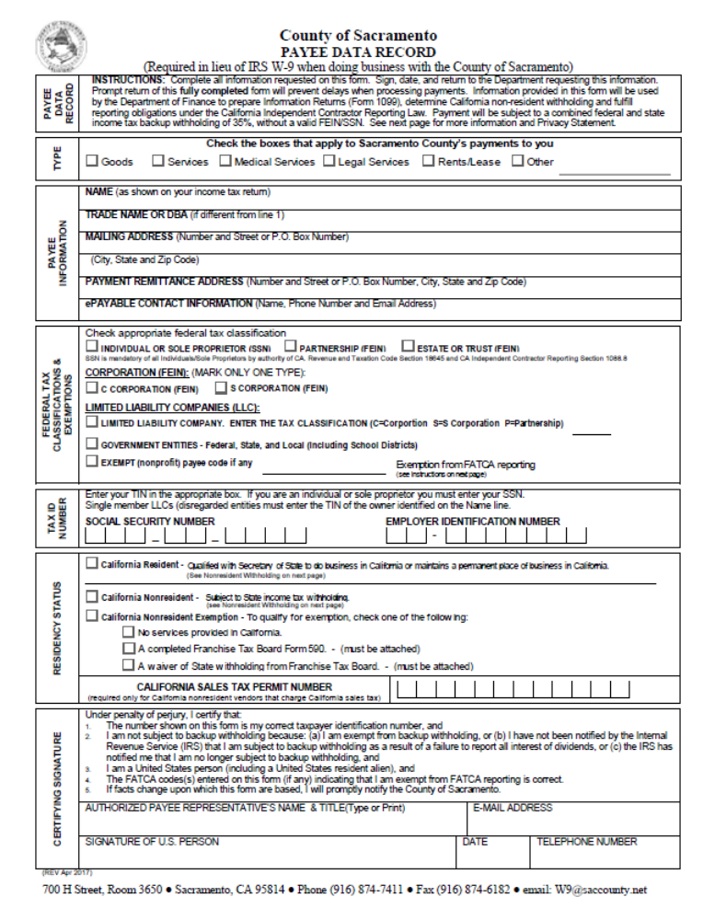
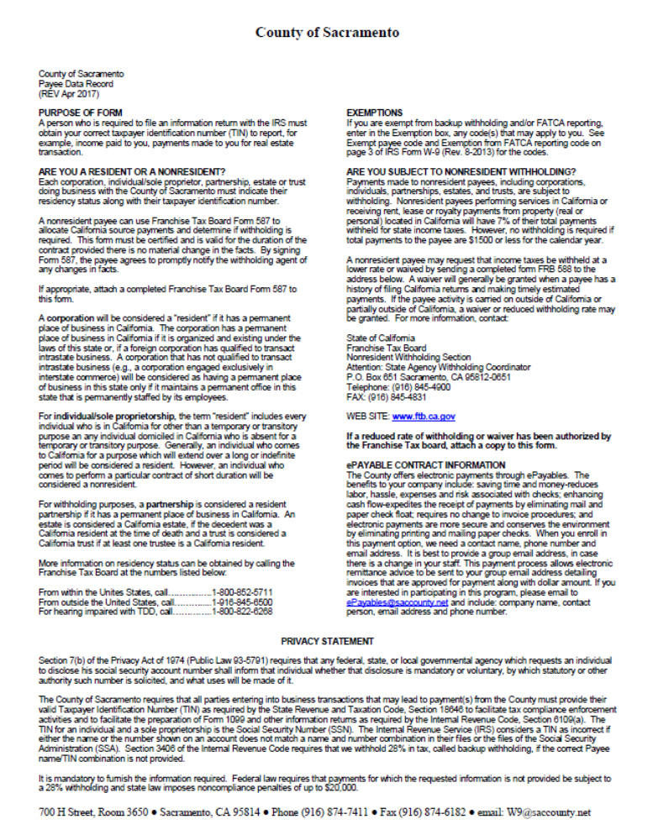

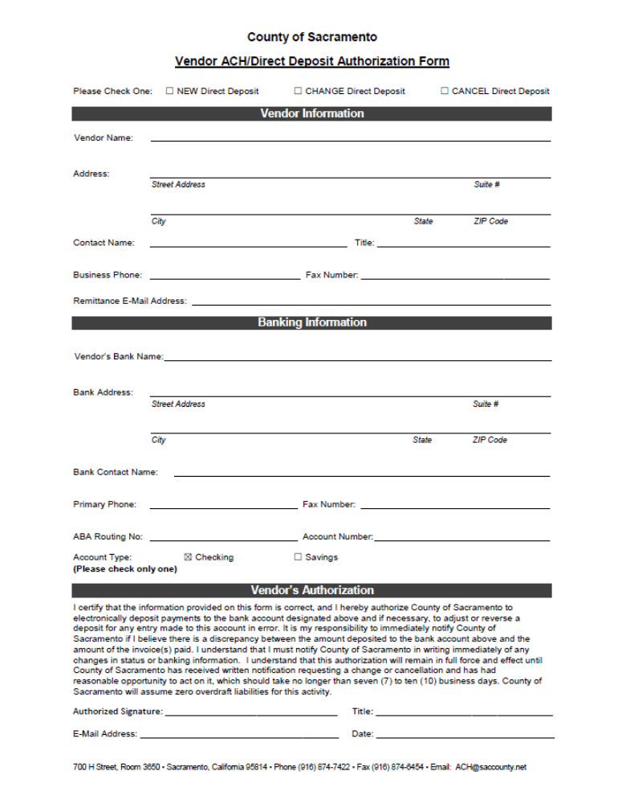
EXHIBIT F
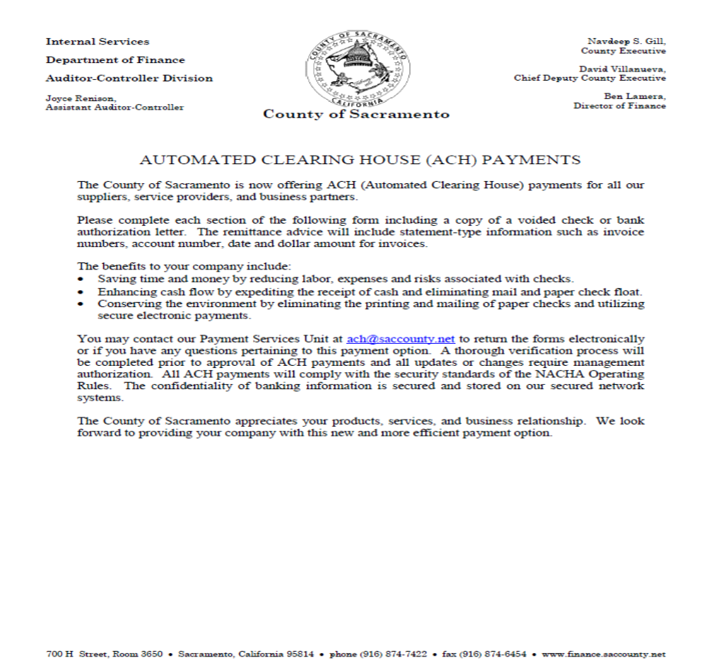

EXHIBIT 10-K
Consultant Certification of Contract Costs and Financial
Management System
(Note: If requesting to utilize the Safe Harbor Indirect Cost Rate submit Attachment 1 of
DLA-OB 13-07 - Safe Harbor Indirect Cost Rate for Consultant Contracts found at http://www.dot.ca.gov/hq/LocalPrograms/DLA_OB/DLA_OB.htm in lieu of this form.)

Certification of Final Indirect Costs:

Consultant Firm Name: _____________________________________________________

Indirect Cost Rate: _______________ * for fiscal period _____________ (mm/dd/yyyy to mm/dd/yyyy)

*Fiscal period covered for Indirect Cost Rate developed (not the contract period).

Local Government: SACRAMENTO AREA COUNCIL OF GOVERNMENTS

Contract Number: ___________________ Project Number: _____________________

I, the undersigned, certify that I have reviewed the proposal to establish final indirect cost rates for the fiscal period as specified above and to the best of my knowledge and belief:

- All costs included in this proposal to establish final Indirect Cost Rates are allowable in accordance with the cost principles of the Federal Acquisition Regulations (FAR) of Title 48, Code of Federal Regulations (CFR), Part 31.
- This proposal does not include any costs which are expressly unallowable under the cost principles of the FAR of 48 CFR, Part 31.

All known material transactions or events that have occurred affecting the firm’s ownership, organization, and Indirect Cost Rates have been disclosed as of the date of proposal preparation noted above.

Certification of Financial Management System:

I, the undersigned, certify to the best of my knowledge and belief that our Financial Management System meets the standards for financial reporting, accounting records, internal and budget control as set forth in the FAR of Title 49, CFR, Part 18.20 to the extent applicable to Consultant.

Certification of Dollar Amount for all A&E Contracts:

I, the undersigned, certify that the approximate dollar amount of all A&E contracts awarded by Caltrans or a California local agency to this firm within the last three (3) calendar years for all State DOT and Local Agencies is $________________________ and the number of states in which the firm does business is ________.

Certification of Direct Costs:

I, the undersigned, certify to the best of my knowledge and belief that all direct costs identified on the cost proposal(s) in this contract are reasonable, allowable and allocable to the contract in accordance with the cost principles of the FAR of Title 48, CFR, Part 31. Allowable direct costs to a Government contract shall be:

- Compliant with Generally Accepted Accounting Principles (GAAP) and standards promulgated by the Cost Accounting Standards Board (when applicable).
- Compliant with the terms of the contract and is incurred specifically for the contract.
- Not prohibited by 23 CFR, Chapter 1, Part 172 – Administration of Engineering and Design Related Service Contracts to the extent requirements are applicable to Consultant.

All costs must be applied consistently and fairly to all contracts. All documentation of compliance must be retained in the project files.

Subconsultants (if applicable)
Proposed Contract Amount (or amount not to exceed if on-call contract): $ ______________

Prime Consultants (if applicable)
Proposed Total Contract Amount (or amount not to exceed if on-call contract): $ _________

Prime, list all subconsultants and proposed subcontract dollar amounts (attach additional page if necessary):

_______________________________________ $_____________________
_______________________________________ $_____________________
_______________________________________ $_____________________
_______________________________________ $_____________________
_______________________________________ $_____________________

Consultant Certifying (Print Name and Title):

Name: __________________________________________________________________

Title: ___________________________________________________________________

Consultant Certification Signature **: ______________________________________

Date of Certification (mm/dd/yyyy): _______________________
Consultant Contact Information:

Email: ______________________________________________________________

Phone number: _______________________________________

**An individual executive or financial officer of the consultant’s organization at a level no lower than a Vice President or Chief Financial Officer, or equivalent, who has authority to represent the financial information utilized to establish the Indirect Cost Rate proposal submitted in conjunction with the contract.

Note: Per 23 U.S.C. 112(b)(2)(B), Subconsultants must comply with the FAR Cost Principles contained in 48 CFR, Part 31.
23 CFR Part 172.3 Definitions state: Consultant means the individual or firm providing engineering and design related services as a party to the contract. Therefore, subconsultants as parties of a contract must complete a certification and send originals to A&I and keep copies in Local Agency Project Files.

Distribution: 1) Original to Caltrans Audits and Investigations
2) Retained in Local Agency Project Files

EXHIBIT 10-I
NOTICE TO PROPOSERS DBE INFORMATION

The Agency has established a DBE goal for this Contract of 60 %
OR
The Agency has not established a goal for this Contract. However, proposers are encouraged to obtain DBE participation for this contract.

- TERMS AS USED IN THIS DOCUMENT
  - The term “Disadvantaged Business Enterprise” or “DBE” means a for-profit small business concern owned and controlled by a socially and economically disadvantaged person(s) as defined in Title 49, Code of Federal Regulations (CFR), Part 26.5.
  - The term “Agreement” also means “Contract.”
  - Agency also means the local entity entering into this contract with the Contractor or Consultant.
  - The term “Small Business” or “SB” is as defined in 49 CFR 26.65.

- AUTHORITY AND RESPONSIBILITY
- DBEs and other small businesses are strongly encouraged to participate in the performance of Contracts financed in whole or in part with federal funds (See 49 CFR 26, “Participation by Disadvantaged Business Enterprises in Department of Transportation Financial Assistance Programs”). The Consultant must ensure that DBEs and other small businesses have the opportunity to participate in the performance of the work that is the subject of this solicitation and should take all necessary and reasonable steps for this assurance. The proposer must not discriminate on the basis of race, color, national origin, or sex in the award and performance of subcontracts.
- Proposers are encouraged to use services offered by financial institutions owned and controlled by DBEs.

- SUBMISSION OF DBE INFORMATION
If there is a DBE goal on the contract, Exhibit 10-O1 Consultant Proposal DBE Commitment must be included in the Request for Proposal. In order for a proposer to be considered responsible and responsive, the proposer must make good faith efforts to meet the goal established for the contract. If the goal is not met, the proposer must document adequate good faith efforts. All DBE participation will be counted towards the contract goal; therefore, all DBE participation shall be collected and reported.
Exhibit 10-O2 Consultant Contract DBE Information must be included with the Request for Proposal. Even if no DBE participation will be reported, the successful proposer must execute and return the form.

- DBE PARTICIPATION GENERAL INFORMATION
It is the proposer’s responsibility to be fully informed regarding the requirements of 49 CFR, Part 26, and the Department’s DBE program developed pursuant to the regulations. Particular attention is directed to the following:
- A DBE must be a small business firm defined pursuant to 13 CFR 121 and be certified through the California Unified Certification Program (CUCP).
- A certified DBE may participate as a prime consultant, subconsultant, joint venture partner, as a vendor of material or supplies, or as a trucking company.
- A DBE proposer not proposing as a joint venture with a non-DBE, will be required to document one or a combination of the following:
  - The proposer is a DBE and will meet the goal by performing work with its own forces.
  - The proposer will meet the goal through work performed by DBE subconsultants, suppliers or trucking companies.
  - The proposer, prior to proposing, made adequate good faith efforts to meet the goal.
- A DBE joint venture partner must be responsible for specific contract items of work or clearly defined portions thereof. Responsibility means actually performing, managing, and supervising the work with its own forces. The DBE joint venture partner must share in the capital contribution, control, management, risks and profits of the joint venture commensurate with its ownership interest.
- A DBE must perform a commercially useful function pursuant to 49 CFR 26.55, that is, a DBE firm must be responsible for the execution of a distinct element of the work and must carry out its responsibility by actually performing, managing and supervising the work.
- The proposer shall list only one subconsultant for each portion of work as defined in their proposal and all DBE subconsultants should be listed in the bid/cost proposal list of subconsultants.
- A prime consultant who is a certified DBE is eligible to claim all of the work in the Contract toward the DBE participation except that portion of the work to be performed by non-DBE subconsultants.

- RESOURCES
- The CUCP database includes the certified DBEs from all certifying agencies participating in the CUCP. If you believe a firm is certified that cannot be located on the database, please contact the Caltrans Office of Certification toll free number 1-866-810-6346 for assistance.
- Access the CUCP database from the Department of Transportation, Office of Business and Economic Opportunity Web site at: http://www.dot.ca.gov/hq/bep/.
  - Click on the link in the left menu titled Disadvantaged Business Enterprise;
  - Click on Search for a DBE Firm link;
  - Click on Access to the DBE Query Form located on the first line in the center of the page. Searches can be performed by one or more criteria. Follow instructions on the screen.

- MATERIALS OR SUPPLIES PURCHASED FROM DBES COUNT TOWARDS THE DBE GOAL UNDER THE FOLLOWING CONDITIONS:
- If the materials or supplies are obtained from a DBE manufacturer, count 100 percent of the cost of the materials or supplies. A DBE manufacturer is a firm that operates or maintains a factory, or establishment that produces on the premises the materials, supplies, articles, or equipment required under the Contract and of the general character described by the specifications.
- If the materials or supplies purchased from a DBE regular dealer, count 60 percent of the cost of the materials or supplies. A DBE regular dealer is a firm that owns, operates or maintains a store, warehouse, or other establishment in which the materials, supplies, articles or equipment of the general character described by the specifications and required under the Contract are bought, kept in stock, and regularly sold or leased to the public in the usual course of business. To be a DBE regular dealer, the firm must be an established, regular business that engages, as its principal business and under its own name, in the purchase and sale or lease of the products in question. A person may be a DBE regular dealer in such bulk items as petroleum products, steel, cement, gravel, stone or asphalt without owning, operating or maintaining a place of business provided in this section.
- If the person both owns and operates distribution equipment for the products, any supplementing of regular dealers’ own distribution equipment shall be, by a long-term lease agreement and not an ad hoc or Agreement-by-Agreement basis. Packagers, brokers, manufacturers’ representatives, or other persons who arrange or expedite transactions are not DBE regular dealers within the meaning of this section.
- Materials or supplies purchased from a DBE, which is neither a manufacturer nor a regular dealer, will be limited to the entire amount of fees or commissions charged for assistance in the procurement of the materials and supplies, or fees or transportation charges for the delivery of materials or supplies required on the job site, provided the fees are reasonable and not excessive as compared with fees charged for similar services.

EXHIBIT 15-H
DBE Information – Good Faith Efforts
Federal-aid Project No. ______________________________ Bid Opening Date ___________________
The Sacramento Area Council of Governments established a Disadvantaged Business Enterprise (DBE) goal of 60% for this project. The information provided herein shows that a good faith effort was made.

Lowest, second lowest and third lowest bidders shall submit the following information to document adequate good faith efforts. Bidders should submit the following information even if the “Local Agency Bidder DBE Commitment” form indicates that the bidder has met the DBE goal. This will protect the bidder’s eligibility for award of the contract if the administering agency determines that the bidder failed to meet the goal for various reasons, e.g., a DBE firm was not certified at bid opening, or the bidder made a mathematical error.

Submittal of only the “Local Agency Bidder DBE Commitment” form may not provide sufficient documentation to demonstrate that adequate good faith efforts were made.

The following items are listed in the Section entitled “Submission of DBE Commitment” of the Special Provisions:
A. The names and dates of each publication in which a request for DBE participation for this project was placed by the bidder (please attach copies of advertisements or proofs of publication):

Publications |  | Dates of Advertisement
_________________________________________________________________
_________________________________________________________________
_________________________________________________________________

B. The names and dates of written notices sent to certified DBEs soliciting bids for this project and the dates and methods used for following up initial solicitations to determine with certainty whether the DBEs were interested (please attach copies of solicitations, telephone records, fax confirmations, etc.):

Names of DBEs Solicited |  | Date of Initial Solicitation |  | Follow Up Methods and Dates
_________________________________________________________________________
_________________________________________________________________________
_________________________________________________________________________

The items of work which the bidder made available to DBE firms including, where appropriate, any breaking down of the contract work items (including those items normally performed by the bidder with its own forces) into economically feasible units to facilitate DBE participation. It is the bidder’s responsibility to demonstrate that sufficient work to facilitate DBE participation was made available to DBE firms.

Items of Work | Bidder Normally Performs Item (Y/N) | Breakdown of Items | Amount  ($) | Percentage  Of  Contract
_________________________________________________________________________
_________________________________________________________________________
_________________________________________________________________________

D. The names, addresses and phone numbers of rejected DBE firms, the reasons for the bidder’s rejection of the DBEs, the firms selected for that work (please attach copies of quotes from the firms involved), and the price difference for each DBE if the selected firm is not a DBE:

Names, addresses and phone numbers of rejected DBEs and the reasons for the bidder’s rejection of the DBEs:

Names, addresses and phone numbers of firms selected for the work above:

E. Efforts made to assist interested DBEs in obtaining bonding, lines of credit or insurance, and any technical assistance or information related to the plans, specifications and requirements for the work which was provided to DBEs:

F. Efforts made to assist interested DBEs in obtaining necessary equipment, supplies, materials or related assistance or services, excluding supplies and equipment the DBE subcontractor purchases or leases from the prime contractor or its affiliate:
________________________________________________________________________
________________________________________________________________________
________________________________________________________________________
________________________________________________________________________

- The names of agencies, organizations or groups contacted to provide assistance in contacting, recruiting and using DBE firms (please attach copies of requests to agencies and any responses received, i.e., lists, Internet page download, etc.):

Name of Agency/Organization |  | Method/Date of Contact |  | Results
________________________________________________________________________
________________________________________________________________________

H. Any additional data to support a demonstration of good faith efforts (use additional sheets if necessary):
________________________________________________________________________
________________________________________________________________________

NOTE: USE ADDITIONAL SHEETS OF PAPER IF NECESSARY

EXHIBIT 10-O1
CONSULTANT PROPOSAL DBE COMMITMENT

1. Local Agency: Sacramento Area Council of Governments 2. Contract DBE Goal: 60%
3. Project Description: Challenge #1 - Custom Computer Programming Services
4. Project Location:
5. Consultant's Name: | 6. Prime Certified DBE: □

7. Description of Work, Service, or Materials Supplied | 8. DBE Certification  Number | 9. DBE Contact Information | 10. DBE %
Local Agency to Complete this Section |  | 11. TOTAL CLAIMED DBE PARTICIPATION | %
17. Local Agency Contract Number: |  | 11. TOTAL CLAIMED DBE PARTICIPATION | %
18. Federal-Aid Project Number: |  | 11. TOTAL CLAIMED DBE PARTICIPATION | %
19. Proposed Contract Execution Date: |  | 11. TOTAL CLAIMED DBE PARTICIPATION | %
Local Agency certifies that all DBE certifications are valid and information on this form is complete and accurate. |  | IMPORTANT: Identify all DBE firms being claimed for credit, regardless of tier. Written confirmation of each listed DBE is required.  12. Preparer's Signature 13. Date  14. Preparer's Name 15. Phone  16. Preparer's Title
20. Local Agency Representative's Signature 21. Date

22. Local Agency Representative's Name 23. Phone
24. Local Agency Representative's Title

DISTRIBUTION: Original – Included with consultant’s proposal to local agency.

EXHIBIT G


EXHIBIT H

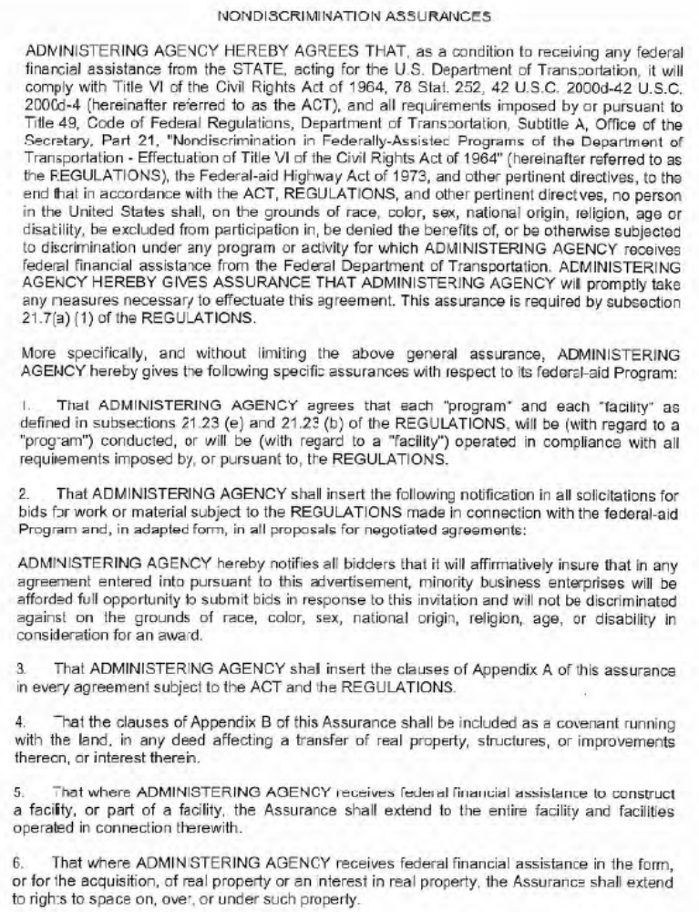

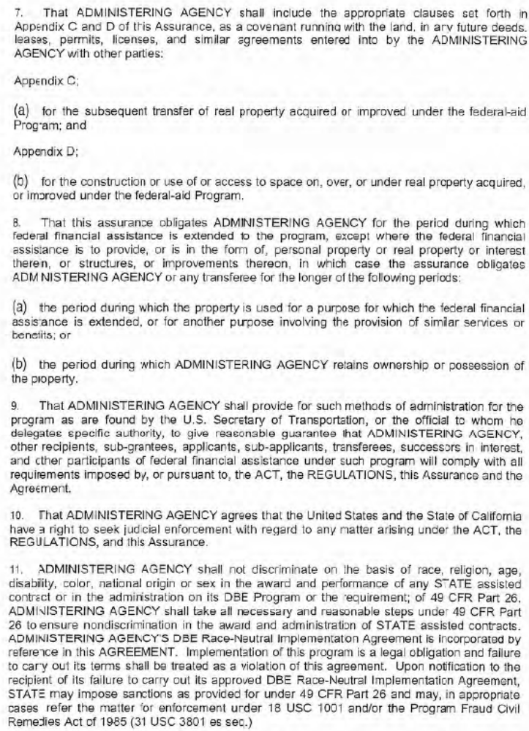
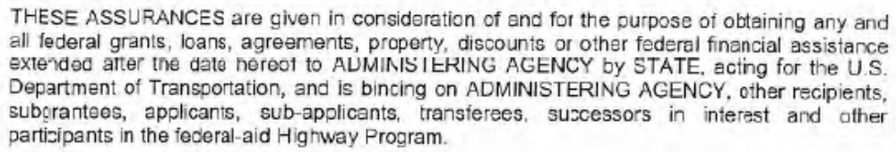

APPENDIX A TO EXHIBIT H

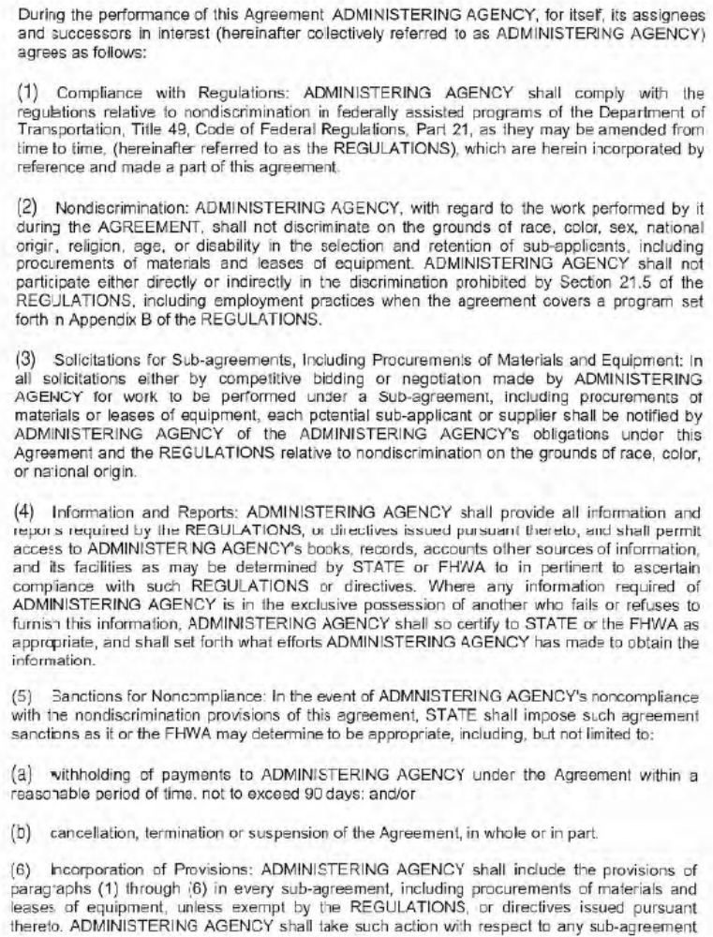
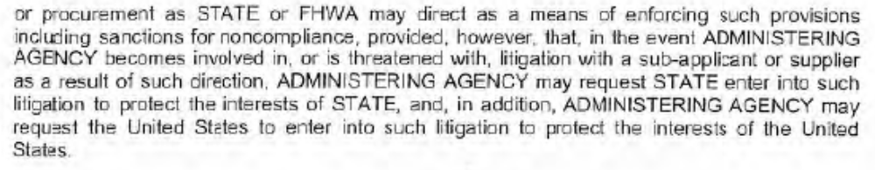

APPENDIX B TO EXHIBIT H

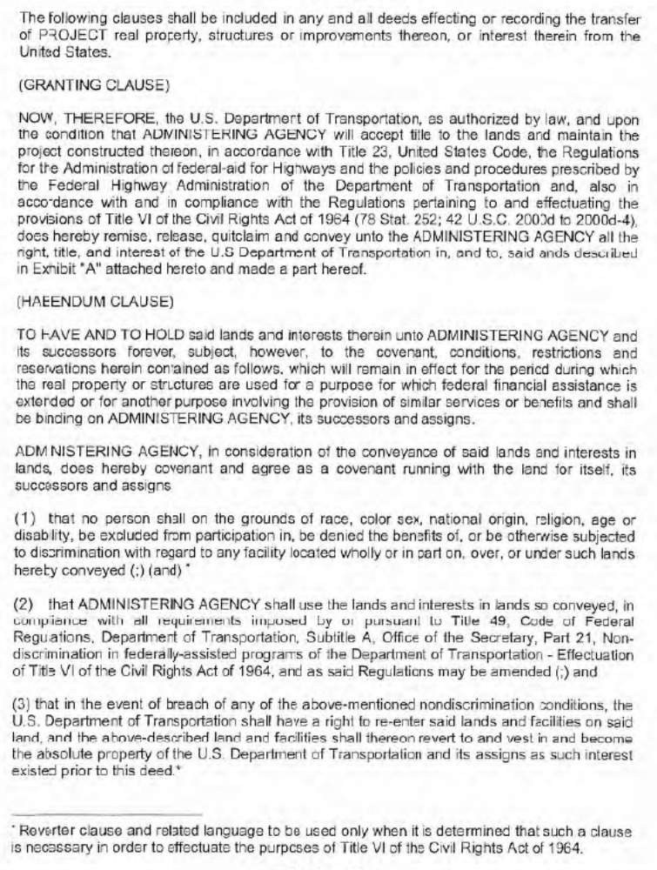

APPENDIX C TO EXHIBIT H

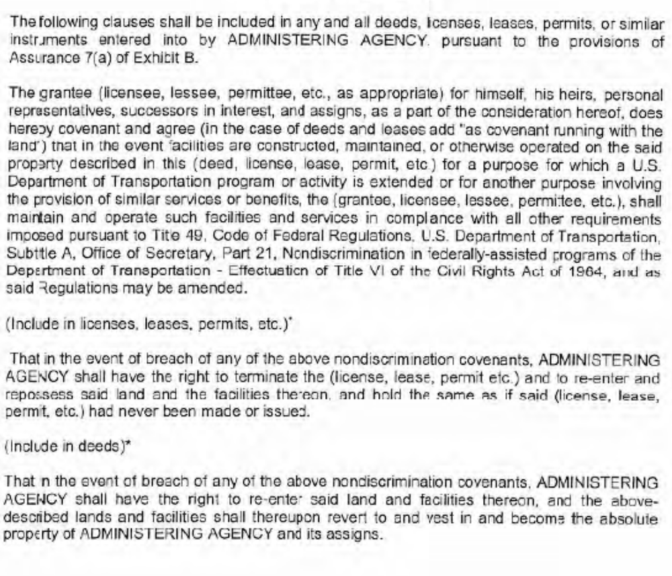

APPENDIX D TO EXHIBIT H

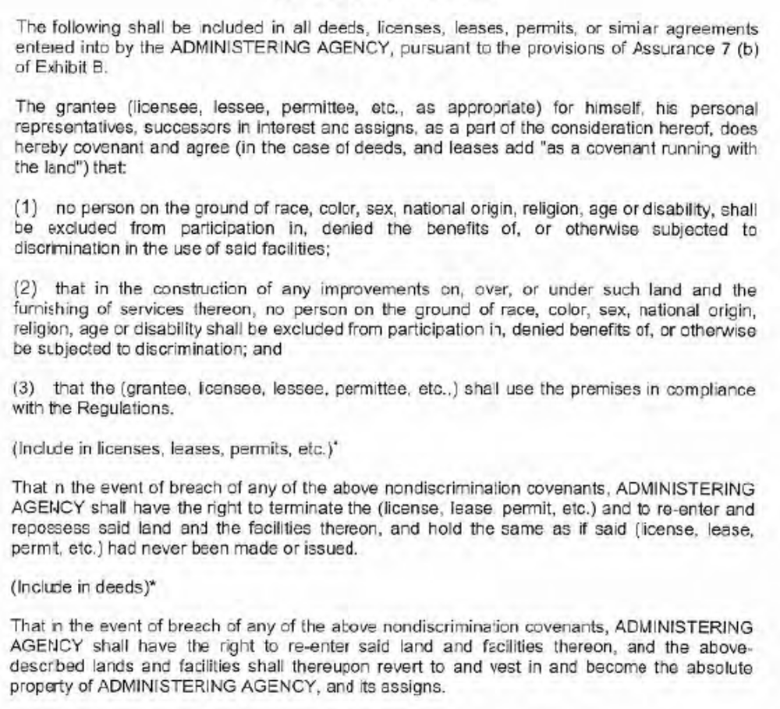

EXHIBIT I
SACOG REQUIRED SUPPORTING DOCUMENTATION FOR INVOICE



